Contents of Report:
- ABSTRACT
- INDEX
- Chapter 1-Introduction
- Chapter 2-Analysis
- Chapter-3 Design
- Chapter-4 Implementation
- Chapter-5 Screenshots
- Chapter-6 Conclusion

ABSTRACT:

This is a small scale project for Online Used Bike Selling system. The basic idea is that customer can buy used bike using online. The administrator can enter the name and password and can create an account and after that he is able see all the information of register user as well as what the post to selling.
Online Bike selling system app provide flexibility to any customer/user, so that he is freely to see advertisement which is posted by bike owner.
The Online Bike selling system enables any user to set up online account, after that he is able to post an ad of his used bike, and a system administrator to approve and reject requests for new ads and maintain lists of customers. Also on the agenda is to design an online bike selling site which is to manage the used bike information in the shop and also helps to customers to purchase that used bike without any hectic and without visiting seller’s place. In Our website there you find out all the specification regarding used bike. Online used bike selling app will use the internet as the sole method for selling used bike to its consumers. Bike selling application will provide to see any number of used bike’s ads and after that user can compare which one is best fit for it’s need, and also in our website advertiser is also able to post image of it’s used bike so that is it beneficial to sell your bike.
It is an online used bike selling store that enables bike owners to sell their used bike. It is a web where you can also find out all the details regarding to that bike like bike name, used your, price, bike image. This website will be useful to
anyone who wants to purchase used bike using internet.

INDEX:

CHAPTER NO. | TOPIC | PAGE NO.
1 | INTRODUCTION | 5
2 | ANALYSIS
2.1 | STUDY OF THE SYSTEM | 6
2.2 | PROJECT SCOPE | 7
2.3 | OBJECTIVES | 8
3 | DESIGN | 9
4 | IMPLEMENTATION | 10

CHAPTER-1

INTRODUCTION:

The aim of this project is on the online used bike selling application it is developed
using HTML5, CSS,BOOTSTRAP,PYTHON,DJANGO,MTSQL. The application is very
useful where the buyer can directly buy the used bike from home via internet
on mobile or system. The application reduces lot of work load for customer as
well as owner.
By this online application the product is directly post by the customer to the customer, hence there is no third party (deailer) allow so buyers no need to pay any commission.

CHAPTER-2

ANALYSIS:
2.1.STUDY OF THE SYSTEM
MODULES:
The system after careful analysis has been identified to be presented with the following modules and roles.
The modules involved are:

➢ Administrator
➢ Moderators
➢ Users

2.1.1 ADMINISTRATOR:
The administrator is the super user of this application. Only admin have access into this admin page. Admin may be the owner of the shop. The administrator has all the information about all the users and about all products.
This module is divided into different sub-modules.
1. Manage Moderators
2. Manage Products
3. Manage Users
4. Manage Orders

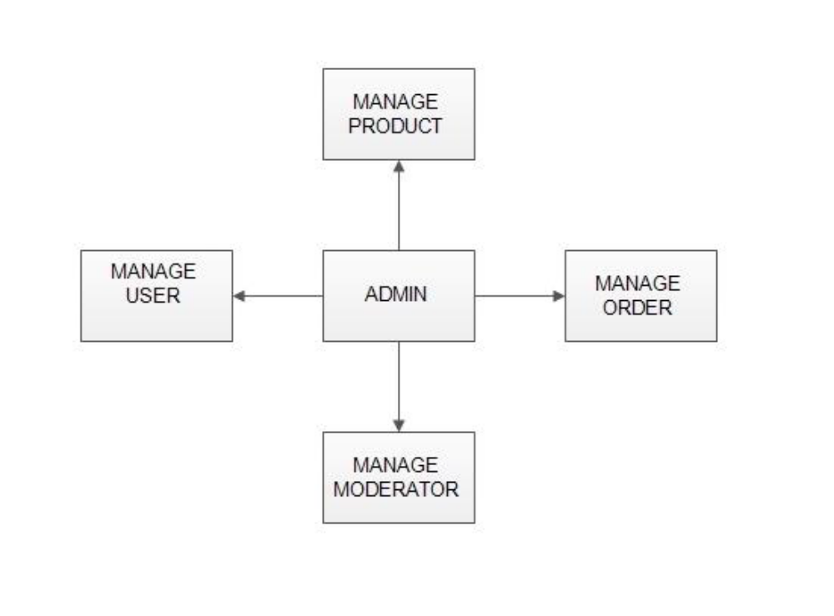

- MANAGE MODERATOR
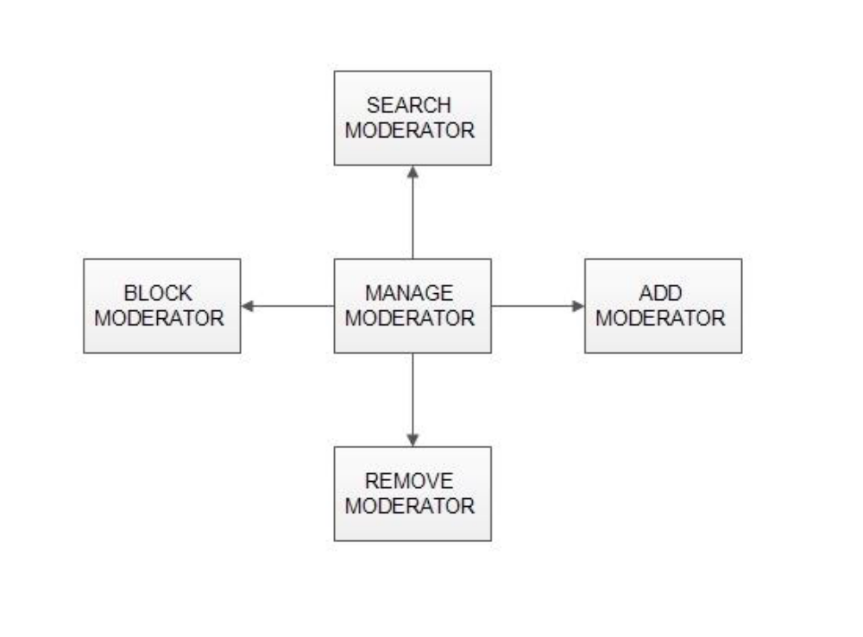

➢ Add Moderator
Only admin is having the privilege to add a moderator. A moderator can be considered as a staff who manages the orders or owner of a group of products.

➢ Block moderator
Admin can restrict a moderator from managing the orders by blocking them. Admin can unblock a blocked user if needed.

➢ Remove Moderator
Admin has privilege to delete a moderator who was added.

➢ Search moderator:
All existing moderators can be viewed by the administrator as a list. If there is number of moderators and admin need to find one of them, the admin can search for a moderator by name.

- MANAGE PRODUCTS
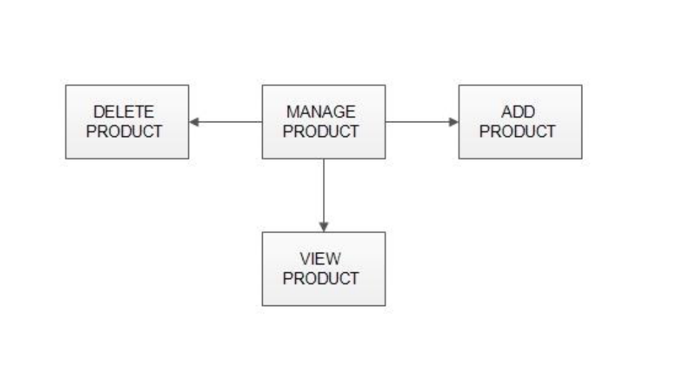
➢ Add Products
The shopping cart project contains different kind of products. The products can be classified into different categories by name. Admin can add new products into the existing system with all its details including an image.

➢ Delete Products
Administrator can delete the products based on the stock of that particular product.

➢ Search products
Admin will have a list view of all the existing products. He can also search for a particular product by name.

3.MANAGE USER
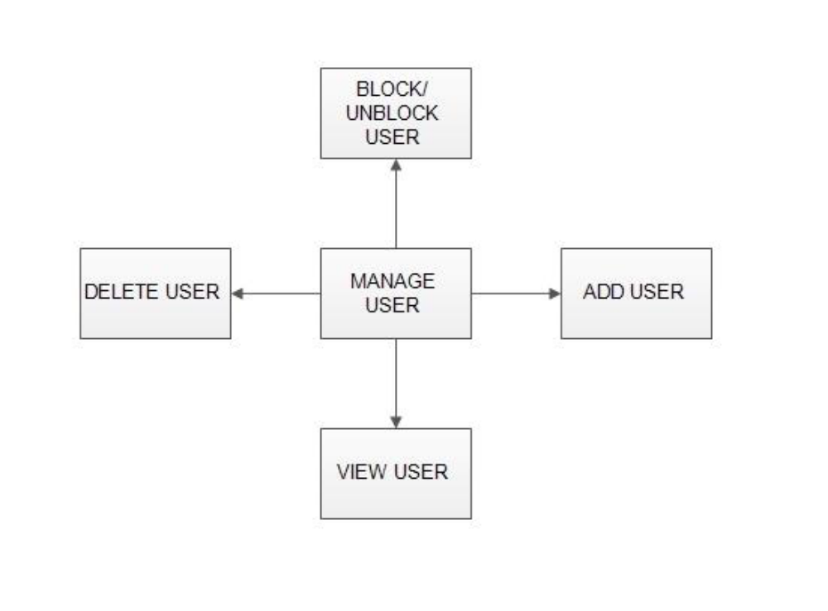

➢ View Users
The admin will have a list view of all the users registered in the system. Admin can view all the details of each user in the list except password.

➢ Add Users
Admin has privileges to add a user directly by providing the details.

➢ Delete &Block Users
Administrator has a right to delete or block a user. The default status of a new user registered is set as blocked. The admin must accept the new user by unblocking him.
4.MANAGE ORDERS
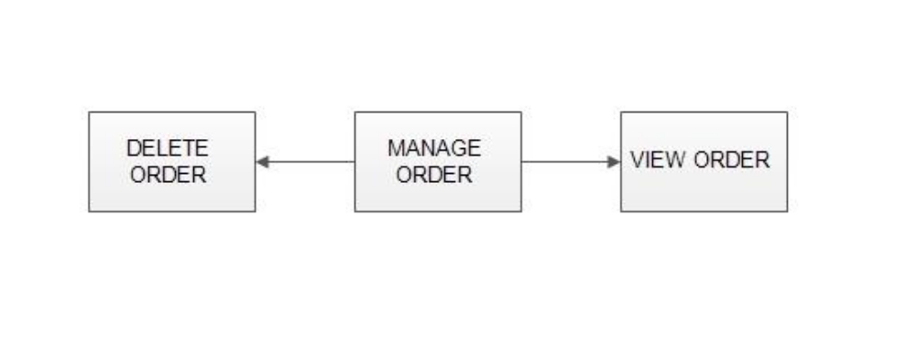

➢ View Order
Administrator can view the Orders which is generated by the users. He can verify the details of the purchase.

➢ Delete order
Admin can delete order from the orders list when the product is taken for delivery.
2.1.2 MODERATORS

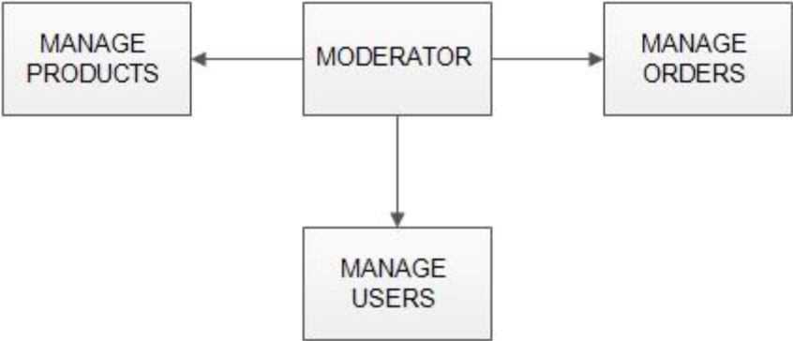
A moderator is considered as a staff who can manage orders for the time being. As a future update moderator may give facility to add and manage his own products . Moderators can reduce the work load of admin. Now moderator has all the privilege an admin having except managing other moderators. He can add products and users. He can also check the orders and edit his profile.
➢ Manage products
➢ Manage users
➢ Manage orders
2.1.3 USERS

➢ View Users
The admin will have a list view of all the users registered in the system. Admin can view all the details of each user in the list except password.

➢ Add Users
Admin has privileges to add a user directly by providing the details.

➢ Delete &Block Users
Administrator has a right to delete or block a user. The default status of a new user registered is set as blocked. The admin must accept the new user by unblocking him.

2.2.Project Scope
The supplementary specification applies to online shopping system. This specification defines the non-functional requirement of the system such as:
Functionality:
Since it stand alone application, one or more user may use it at a time.
Usability:
Desktop interface
Windows 7/8/10
Technology:
Front End : HTML5,CSS,Bootstrap.
Back End : Python,Django
Database : MySql

2.3. Objectives
The purpose of this document is to define the requirements of Online bike selling system. This supplementary specification lists the requirements that are not readily captured in the use case model. Supplementary specification and the use case model capture a complete set of requirement of the system.

CHAPTER-3

DESIGN:
1.DFD :
A data flow model is diagrammatic representation of the flow and exchange of information within a system. Data flow models are used to graphically represent the flow of data in an information system by describing the processes involved in transferring data from input to file storage and reports generation.
A data flow model may also be known as a data flow diagram (DFD).
1.1 Level zero (context level) :

ADMIN
USER

APPLICATION

1.2 Level Two:
USER

2.0
login
1.0
Display ads
1.1
Add ads

1.2
Check it user register or not
1.3
User register login page
2.1
Auth.

Generate report

ADMIN

CHAPTER-4

IMPLEMENTATION:
CODE FOR HOMEPAGE
<!Doctype html>
<html>
<head>
<title>vender Cool and Easy Way To Buy and Sell Products</title>
<meta charset="utf-8">
<meta name="viewport" content="width=device-width, initial-scale=1">
<link rel="stylesheet" href="https://maxcdn.bootstrapcdn.com/bootstrap/4.3.1/css/bootstrap.min.css">
<script src="https://ajax.googleapis.com/ajax/libs/jquery/3.3.1/jquery.min.js"></script>
<script src="https://cdnjs.cloudflare.com/ajax/libs/popper.js/1.14.7/umd/popper.min.js"></script>
<script src="https://maxcdn.bootstrapcdn.com/bootstrap/4.3.1/js/bootstrap.min.js"></script>
</head>
<style>
nav{
background-color: gainsboro;
}
nav a{
color: white;
}
a {
text-decoration: none !important;
}
#firstjumb {
margin-top: 55px;
height: 193px;
}
#firstjumb h3{
margin-bottom: 75px;
margin-top: 2px;
font-size: 24px;
}
#firstjumb h1{
margin-bottom: 50px;
margin-top: -63px;
font-size: 18px;
}
body{
background-image: url("https://images.unsplash.com/photo-1540281985221-2dbab6da4078?ixlib=rb-1.2.1&ixid=eyJhcHBfaWQiOjEyMDd9&auto=format&fit=crop&w=890&q=80");
background-size: cover;
background-repeat: no-repeat;
}
img{
width: 200px;
height: 200px;
margin-left: 10%;
margin-top: 5%;
}
#content{
width: 280px;
margin-left: 30px;
border-left: 4px solid darkslateblue;
}
img:hover{
width: 210px;
height: 210px;
}
#imgtag{
width: 280px;
height: 250px;
padding: 2%;
}
.thumbnail{
width: 300px;
height: 300px;
}
.col1{
padding: 2%;
}
</style>
<body>
<div id="firstjumb" class="jumbotron">
<h3 style="font-size: 24px;font-family:sans-serif;">vender</h3>
<h1 style="font-size: 18px"> cool and easy way to buy and sell products</h1>
</div>
<nav class="navbar navbar-expand-sm fixed-top">
<div class="container">
<div class="nav navbar-header">
<a href="{% url 'home' %}" class="navbar-brand">Home</a>
<div class="navbar-nav">
<ul class="navbar-nav">
<li class="nav-item">
<a class="nav-link" href="{% url 'login' %}">Post an ad</a>
</li>
</ul>
</div>
</div>
</div>
</nav>
<br>
<div class="container">
<div style="border-radius: 25px" class="jumbotron">
{% if data %}
<div class="row">
{% for d in data %}
<div class="col-md-4 ">
<div class="thumbnail">
<div id="imgtag">
<img style="border-radius: 5%;" src="{{ d.bike_img.url }}" width="300px" height="300px">
</div>
<div id="content">
<a style="color: black;" class="btn-primary" href="{% url 'product_details' %}?id={{ d.product_id }}"><h4>&nbsp;₹{{ d.bike_price }}<br>&nbsp;{{ d.bike_name|title}}</h4></a>
</div>
</div>
</div>
{% endfor %}
</div>
{% else %}
<h3>No data available</h3>
{% endif %}
</div>
</div>
</body>
</html>

CODE FOR DATABASE FOR REGISTRATION
def registration_view(request):
if request.method == 'POST':
rform = UserRegistrationForm(request.POST)
if rform.is_valid():
user_name = request.POST.get('user_name')
user_mobile = request.POST.get('user_mobile')
user_email = request.POST.get('user_email')
password1 = request.POST.get('password1')
password2 = request.POST.get('password2')
check = True
if len(user_name)<5:
rform = UserRegistrationForm()
my_dict = {'rform':rform}
messages.success(request,'User name length must be greater than 5')
return render(request,'registration.html',my_dict)
if (password1 and user_name) in UserRegistrationData.objects.all():
rform = UserRegistrationForm()
my_dict = {'rform':rform}
messages.error(request,'Username already exist')
return render(request,'registration.html',my_dict)
if password1 != password2:
messages.error(request,'Both password must be match')
rform = UserRegistrationForm()
return render(request,'registration.html',{'rform':rform})
if len(str(password1)) >=8:
match = re.fullmatch('[0-9a-zA-Z]*',str(password1))
if match != None:
pass
else:
rform = UserRegistrationForm()
messages.error(request,"Don't use special character")
return render(request,'registration.html',{'rform':rform})
if len(str(password1)) <8:
rform = UserRegistrationForm()
messages.error(request, "Password length must be 8 character")
return render(request, 'registration.html', {'rform': rform})
if (len(str(user_mobile)) < 10):
messages.error(request, 'Please enter a valid number')
rform = UserRegistrationForm()
return render(request, 'registration.html', {'rform': rform})
if len(str(user_mobile)) == 10:
match = re.fullmatch('[6-9][0-9]{9}',user_mobile)
if match != None:
pass
else:
messages.error(request, "Please enter a valid number")
rform = UserRegistrationForm()
return render(request, 'registration.html', {'rform': rform})
if len(str(user_mobile)) > 10:
messages.error(request, "Please enter a valid number")
rform = UserRegistrationForm()
return render(request, 'registration.html', {'rform': rform})
data = UserRegistrationData(
user_name=user_name,
user_mobile=user_mobile,
user_email=user_email,
password1=password1,
password2=password2,
)
data.save()
msg = 'Enter Your Login Details..'
lform = UserLoginForm()
my_dict = {'lform':lform,'msg':msg}
return redirect('/login/')
# return render(request,'login.html',my_dict)
msg = 'Pls Enter Details correctly'
rform = UserRegistrationForm()
my_dict = {'msg':msg,'rform':rform}
messages.success(request, 'Please fill the form Correctly')
return render(request,'registration.html',my_dict)
else:
msg='Fill all the details'
rform = UserRegistrationForm()
my_dict={'msg':msg,'rform':rform}
return render(request, 'registration.html', my_dict)

CODE FOR LOGIN
def login_view(request):
if request.method == 'POST':
lform = UserLoginForm(request.POST)
if lform.is_valid():
user_email = request.POST.get('user_email')
password1 = request.POST.get('password1')
# request.COOKIES['email'] = user_email
# temp = UserRegistrationData.objects.get(user_email=user_email)
# get_id = temp.id
#
user_data = UserRegistrationData.objects.filter(user_email=user_email,password1=password1)
get_id = user_data[0].id
print(get_id,"set")
#request.COOKIES['id'] = get_id
data = UserSellingData.objects.filter(rel_id_id=get_id)
if user_data!=None:
print('above return')
msg = "Please Provide bike information"
my_dict = {'data':data,'msg':msg}
response = render(request,'adpost.html',my_dict)
response.set_cookie('id',get_id)
return response
else:
msg = 'Pls Enter a valid detail...'
lform = UserLoginForm()
my_dict = {'msg': msg, 'lform': lform}
return render(request, 'login.html', my_dict)
else:
msg = 'Please Enter your details'
lform = UserLoginForm()
my_dict = {'lform': lform, 'msg': msg}
return render(request, 'login.html', my_dict)
?>

CODE FOR POST AN AD
def selling_view(request):
print('inside selling view')
if request.method == 'POST':
print('before taking data')
bike_name = request.POST.get('bike_name')
bike_price = request.POST.get('bike_price')
bike_old = request.POST.get('bike_old')
bike_disc = request.POST.get('bike_disc')
mobile = request.POST.get('mobile')
address = request.POST.get('address')
bike_picture = request.FILES['bike_picture']
id = request.COOKIES.get('id')
print(id,'inside post get method')
print(bike_name,bike_price,bike_old,bike_disc,bike_picture,id)
data = UserSellingData(
bike_name=bike_name,
bike_price=bike_price,
bike_old=bike_old,
bike_desc=bike_disc,
bike_img=bike_picture,
currdata=currdate,
mobile=mobile,
address=address,
rel_id_id= int(id),
)
print('before save()')
data.save()
return redirect('home')
else:
msg = 'Pls fills all the details'
return render(request,'adpost.html',{'msg':msg})

HOME:

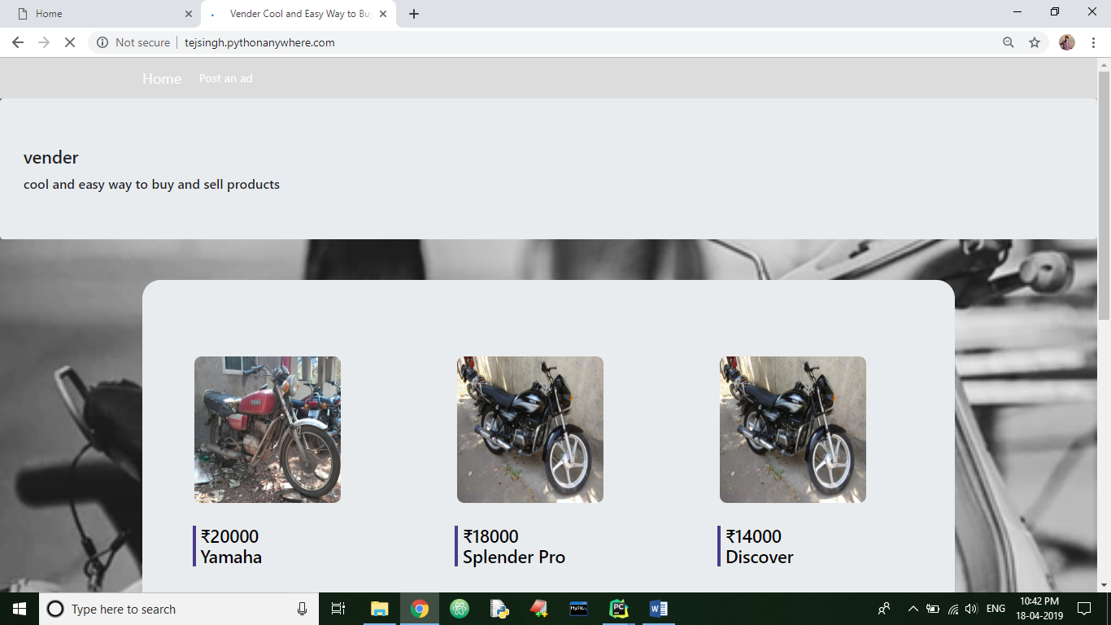

REGISTER:
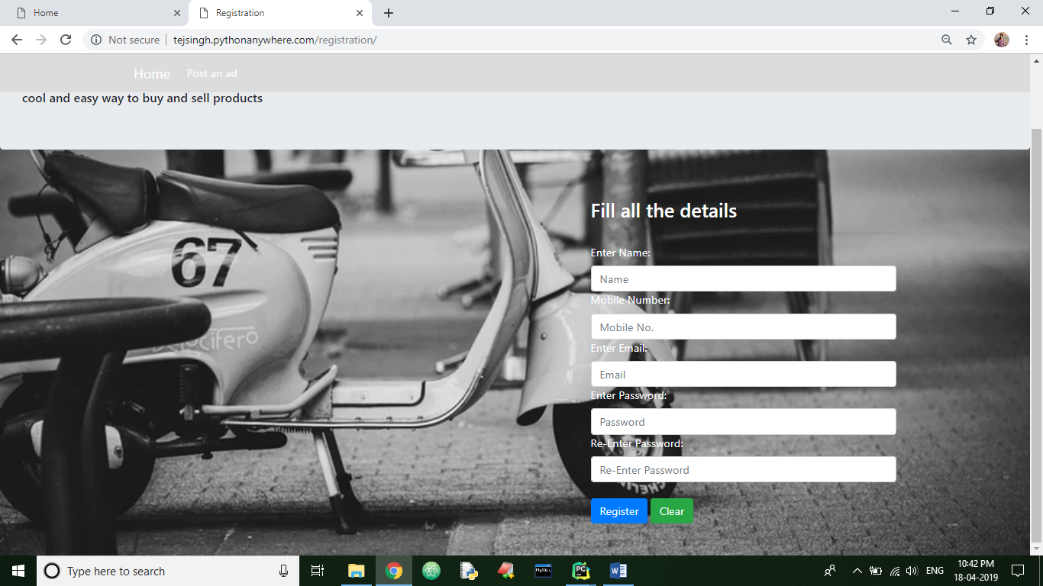

AFTER REGISTER:
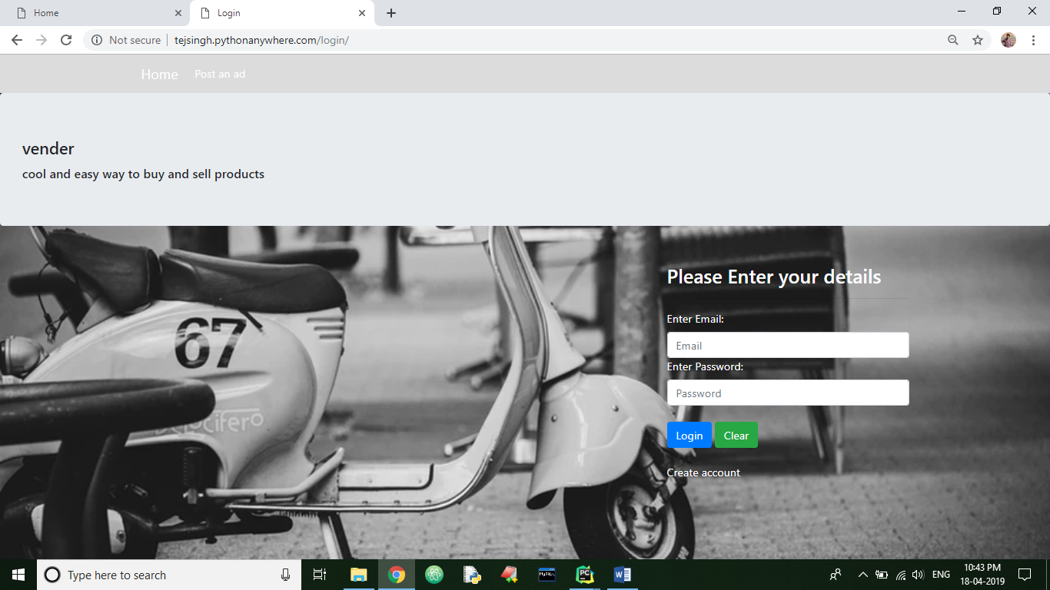

POSTING AN AD:
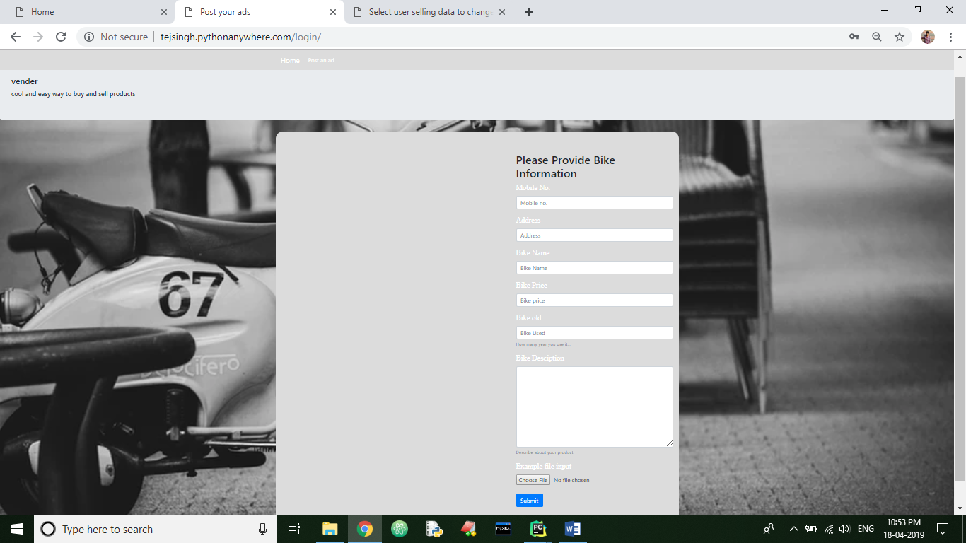

DATABASE UPDATION:
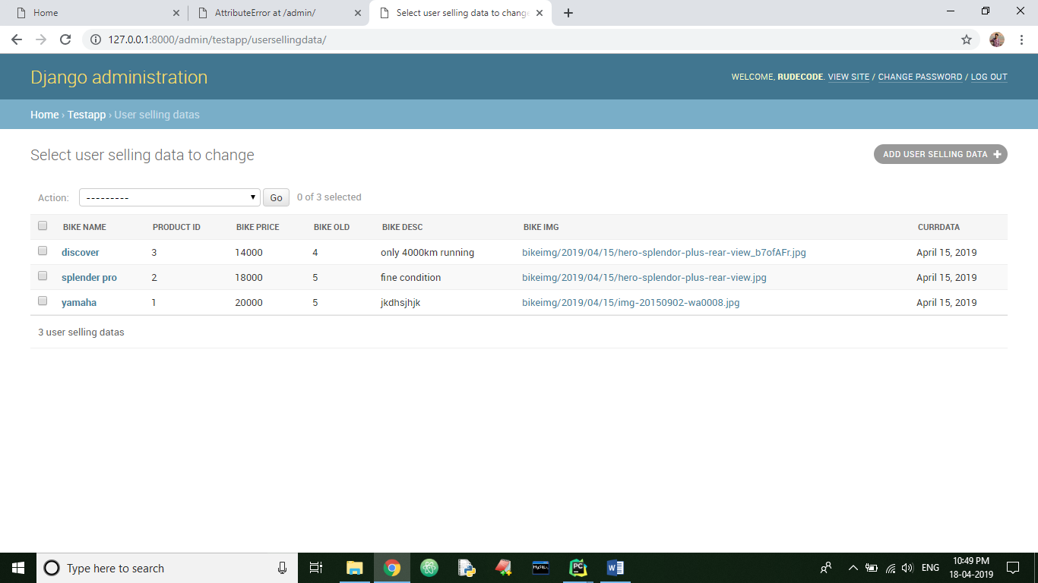

SEENING DESCRIPTION OF THE BIKES:
